Spring Framework

- Spring is an open-source, lightweight framework for building Java applications.
- It provides comprehensive infrastructure support for developing Java enterprise applications.
- It helps developers create applications in a loosely coupled, easily testable, and maintainable way.

Spring Core
- Spring Core is the foundational module of the Spring Framework that provides the essential features for building Java-based applications.
- It mainly offers an Inversion of Control (IoC) container that manages the lifecycle and configuration of application objects (beans) through Dependency Injection (DI).
- This design pattern helps to promote loose coupling between components, making the code more modular, maintainable, and testable.

Key Features of Spring Core
- Inversion of Control (IoC): The container controls the creation, wiring, and lifecycle of objects.
- Dependency Injection (DI): Dependencies are injected into objects by the container rather than the objects creating dependencies themselves.
- Modular and Flexible: Developers can choose and configure only the components they need.
- Supports Loose Coupling: This design makes applications easier to maintain, test, and scale by ensuring components are not tightly dependent on each other. Changes in one component typically do not drastically affect related components in different layers

- Bean Lifecycle Management: Manages the lifecycle and configuration of application beans. Bean is a lightweight object used in the Spring based applications.

Role in Spring Framework

- Spring Core acts as the backbone of the entire Spring Framework, upon which other modules like Spring MVC, Spring Security, and Spring Data are built.
- It simplifies Java application development by handling complexity around object creation and dependency management through configuration and annotations.

IOC

- IOC stands for Inversion of Control. IOC feature of spring framework is responsible for the management of beans (objects) in the Spring based applications.
- Before Spring framework developers were responsible to manage the life cycle of a bean (object) within the application like creating a new object, initializing it, utilizing it whenever required in the application and destroying it if the object is no more required in the application.

- But once after the Spring Framework was introduced, the responsibility of managing the bean (object) life cycle has been given to the spring framework itself where the control of managing the beans has been inverted from the developer to the spring framework, that's why it is called as IOC (Inversion Of Control).

Why was Spring Framework introduced?

- Before Spring, Java developers often used Enterprise JavaBeans (EJBs) for building enterprise applications.
- But EJBs had several limitations like :
- Complexity: Configuration and deployment were complex.
- Heavyweight: Large overhead in terms of runtime and setup.
- Difficult Testing: Tight coupling made unit testing almost impossible
- Rigid Architecture: Changes in one class often required changes across many other classes.

So, Spring was introduced to solve these problems

Spring Containers
- Spring containers are the components of spring framework which are responsible for bean management i.e controlling the entire life cycle of pojo classes objects in Spring based applications.
- POJO classes (plain old java objects) are simple Java classes that do not have restrictions of any frameworks.
- They are :
- independent from any specific technology or framework,
- not inheriting any classes or interfaces.
- usually define domain models(entity), with private fields, all and no args contructors, getters , setters, overriden methods like toString() and sometimes also the object references of another POJO/entity classes.

- The Spring container is responsible for instantiating, configuring, and assembling these objects,acts as an execution environment, allowing developers to focus on business logic rather than boilerplate code related to object creation and management.

- It acts as an interface between low level platform functionality layer(JRE and all java operations) and component layer(DAO/Repository/Service layers)

- It has following containers:

- IOC:
  - Core
  - J2EE

- Web:
(built on the top of IOC, used in spring mvc while creating web applications)

IOC Container
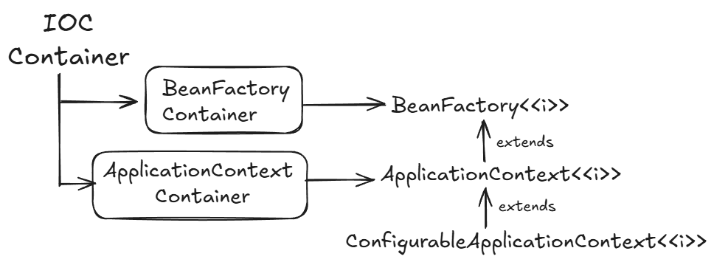

- For an IOC container to perform any operation, POJO classes are required.
- We must implement has-a instead of is-a to establish relationship with multiple entities, (injecting an object/reference of another entity)

- IOC container will read the instructions from configuration xml file, and perform some actions on POJO class like Dependency Injection(DI).

Dependency Injection in Spring based applications
- Dependency Injection is the process where spring containers will provide the required objects in the application whenever there is a demand for the object.
- It is process of taking/reading values/objects from configuration file and injecting them into the POJO classes.
- E.g. Person has a mobile object.
(mobile object can be injected into Person class)

Using Spring Containers

1. Using BeanFactory Container is not recommended as implementation class of BeanFactory interface, XmlBeanFactory is deprecated in Spring 3.1 and removed in Spring 5.

2.Using ApplicationContext Container
- Step 1: In config.xml, add <bean id="demo" class="pojo_classes.Demo"></bean> in main beans tag.

- Class attribute must have fully qualified name of the POJO class.

- Step 2: Use ApplicationContext or ConfigurableApplicationContext to load the info in config.xml file.

- Step 3: Fetch bean/object of POJO class created by Container in Driver class.

- Note: We can configure multiple beans of POJO classes in xml file using bean tag and also load them in driver classes.

- We can also have multiple configuration files in one project

- Create one folder for Configuration files and store all configuration files here.
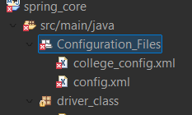
- To access a configuration file:
e.g. ConfigurableApplicationContext context=new ClassPathXmlApplicationContext("Configuration_Files/config.xml");

Bean LifeCycle Methods

- Whenever Spring manages a bean, it takes care of creating it, injecting dependencies, initializing it, and finally destroying it when the container shuts down.

- A Spring bean generally goes through these phases:
- Instantiation → Object of bean class is created.
- Dependency Injection → Spring injects required dependencies (via constructor/setter).
- Initialization (post-construct phase) → After dependencies are set, Spring allows us to run custom initialization logic (this is like post construct).
- Ready for Use → Bean can now be used by the application.
- Destruction (Pre-Destroy phase) → Before container shuts down, Spring calls custom cleanup logic (this is like pre destroy).

- init-method and destroy-method

These are XML-based configuration attributes:
- which method to call after bean creation → init-method
- which method to call before bean destruction → destroy-method

🔹 init-method (post-construct phase)
- Called after Spring finishes dependency injection.
- Used to initialize resources, validate data, or start connections.
- Equivalent to the “post construct” phase.
🔹 destroy-method (Pre-Destroy phase)
- Called before the bean is destroyed (when the container closes).
- Used to release resources, close connections, or cleanup temporary data.
- Equivalent to the “pre destroy” phase.

Annotations used for IOC

- Instead of using multiple tags in configuration file, we can make use of some annotations in out POJO classes, to make the task more easy, readable and more understandable.

- @Component:

- This annotation is a class level annotation , which is used with the class for which we want Spring Container to manage its beans!
- It can be used as a replacement of:

<bean id="xyz " class="fully.qualified.name"></bean>

- In config file, we have to add:
- <!-- @Component annotation -->
- <context:component-scan base-package="pojos"></context:component-scan>

@Component
public class Car
here, bean name will be automatically generated as car
automatic bean name generation is like:

Classname bean name
- Spring spring
- SPRINGCORE SPRINGCORE
- SpringCore springCore

We can also give cutom bean name like:
@Component("car")

- @Value

- We can inject a value into a variable using @Value annotation, as we did using setters and constructors

- E.g @Value(“xyz”)

Eliminating use on xml configuration file, using Config class

- We can implement IOC without using xml configuration file, with the help of configuration class.
- Steps to make a class as a configuration class:

Step 1: Create a class and name it as ConfigClass
Step 2: Use:

@Configuration and @ComponantScan(“base_package_name”) as a class level annotation with ConfigClass

@Configuration:
It is a class-level annotations which indicates that a class declares one or more @Bean methods and may be processed by the Spring container to generate bean definitions and service requests for those beans at runtime.

@ComponentScan: It is a class level annotation which is used with the configuration class.
This annotation is used to help the spring container to look for the classes annotated with @Component , in a specified package in order to manage the beans for the Component classes.

- Note: Here, configuration xml file is not needed at all!!!,
It is completely replaced by Configuration class

Injection using @Autowired

- @Autowired is an annotation provided by Spring that tells the Spring container to automatically inject dependencies into a bean at runtime.

- The sole purpose of @Autowired is to automatically inject (supply) the required dependent objects (beans) into another bean managed by the Spring container.

Using @Autowired with Interface type on reference variable

- Consider the following scenario 1:
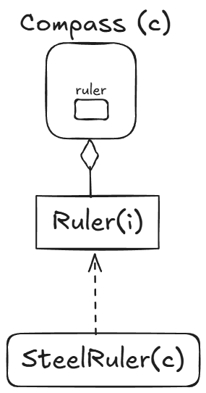

- If we do:
- public class Compass {
- @Autowired
- private Ruler ruler;

- As we know, we cannot create an object for interface, then the question is how the bean will be created?

- Answer:

- Spring Container will check is there any implementing class with @Component annotation present or not.
- If present, Bean of that subclass type will be created and injected into Compass bean!!

- Consider the following scenario 2:
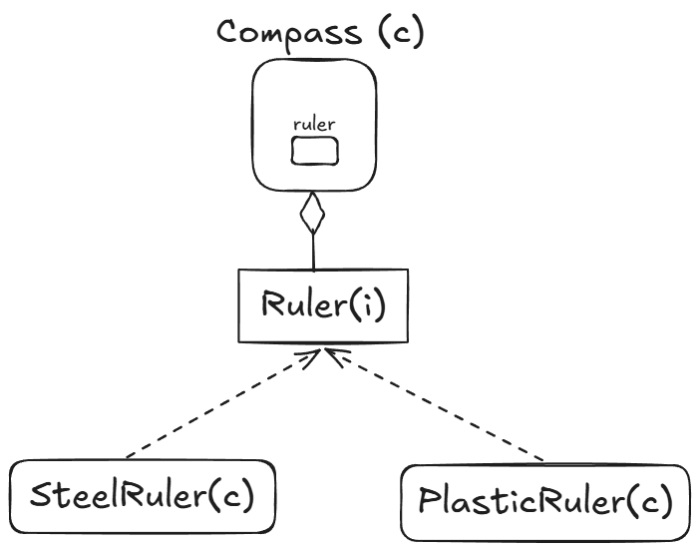

- Now, in this scenario, both the subclass are qualified for bean creation, so Spring Container will get confused about which bean to inject in Compass object .

- So, if we try to fetch bean in this scenario, we will get Exception like this:

UnsatisfiedDependencyException: Error creating bean with name 'compass': Unsatisfied dependency expressed through field 'ruler': No qualifying bean of type 'interfaces.Ruler' available: expected single matching bean but found 2: plasticRuler,steelRuler

- So , to fix this, we can make use of two annotations:

- @Qualifier(“bean_id”):

    - This annotation can be used with reference variable, method or constructor.
    - It is used to tell the Spring Container about the one class among multiple qualified classes, for which the the bean is to be created

- E.g. @Qualifier("plasticRuler")

- @Primary

- It is an alternative of @Qualifier
- It is a class level annotation, which can be used with Either one of the qualified component class for bean creation.
- Spring Container will create the bean of component class with @Primary annotation (in case of multiple qualified component classes) and inject it in the Dependent class(Compass class)
- It indicates that a bean should be given preference when multiple candidates are qualified .

Bean creation using @Bean

- @Bean: It is a method level annotation which is used to indicate that the method produces a bean, to be managed by spring container.
- We can make use of @Bean annotation, if we want IOC Container to create a bean for a class, which is not accessible/editable by us!!
- Here, without @Component annotation, we can create bean for a particular pojo class.
- We have to create a factory method in Configuration class, which will create an object for a particular pojo class.

//factory method to return POJO object
@Bean("duster") //bean name/id
public Duster getDuster()
{
return new Duster();
}

- This method will get invoked once at context startup when ApplicationContext is created by default.

Bean Scope

- In Spring Framework, a bean scope defines how long a bean lives and how many instances of it Spring should create and manage.
- This can be implemented using @Scope annotation

@Scope:
  - This annotation can be used as method level annotation as well as class level annotation
  - It is used to indicate the type of the scope used for returning a produced bean by the spring container.

e.g Class Level:

@Component
@Scope(“prototype”)
public class Emp {

}

Type of scope is singleton by default if not provided!!!

Method level:
@Bean("duster")
@Scope("prototype") // new object will be created for each call of getBeans()
public Duster getDuster() {
return new Duster();
}

- Types of Bean Scopes

- Singleton (Default)
- Only one instance of the bean is created for the entire Spring container.
- Bean production is eager if scope is singleton, as it will create the instance at context startup only.
- So, all the beans fetched using getBean() method will point to same reference i.e reference/address of all beans will be same

e.g. @Component
@Scope () or @Scope(“singleton”)
public class Emp {

}
Use when:
- The bean is stateless (no per-request data).
- The bean performs shared logic or configuration management.
- Example: Services, Repositories, DAO, Controllers, Utility components.

Why:
- Memory efficient (only one instance).
- Better performance (no repeated creation).
- Suitable for shared, thread-safe operations.

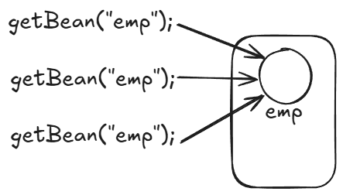
- Prototype

- A new bean instance is created each time it is requested from the container(using getBean()).
- Bean production is lazy if the scope is prototype, as it will create
new bean instance only when it is requested.
- All the beans fetched by getBeans(), will be pointed to different objects. i.e reference/address of all beans will be different

Use when:
- You need a fresh instance every time (stateful objects).
- The bean holds request-specific or session-specific data.
Why:
- Avoids unwanted data sharing between threads or requests.
